Preventing fires
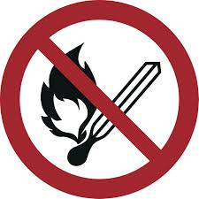

No naked flames; fire, unshielded ignition sources
and smoking prohibited

Behaviour in the event
of a fire
Keep calm
Report the fire | 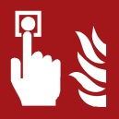  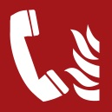 |  | Actuate the manual fire alarm  Emergency number ((0-))112  ((Objektspezifische Notrufnummer eintragen))
Get to safety |    |  | Warn persons at risk / actuate the fire alarm  Assist others in need of help  Close doors  Follow the destined emergency exits  Do not use the lift  Go to the assembly point  Follow instructions
Attempt to extinguish the fire | 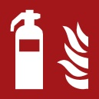  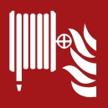  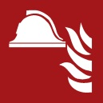 |  | Use the fire extinguisher  Use the fire hose  Use means and devices for fire-fighting (e. g. fire blanket)

Brandschutzordnung nach DIN 14096 / Objekt: Erstelldatum:

Aushang “Verhalten im Brandfall” – Englisch / www.brandschutzdialog.de FeuerTRUTZ Network GmbH

